COMPLAINTS POLICY OF QUEERAF
- QueerAF (‘We’ or ‘Us’) view complaints as an opportunity to learn and improve the quality of our journalism and the contents of our publication(s) for the future, as well as a chance to put things right for the person (or organisation) that has made the complaint.

- Our policy is:
  - To provide a fair complaints procedure that is clear, convenient and easy to use for anyone wishing to make a complaint (in particular those that are vulnerable or who have disabilities)
  - To uphold and adhere to the Standards Code (“Code”) https://impress.press/standards/ set out in the IMPRESS Regulatory Scheme in our assessment of all complaints
  - To publicise the existence of our complaints procedure so that readers know how to contact us to make a complaint
  - To make sure everyone working for us knows what to do if a complaint is received
  - To make sure all complaints are dealt with promptly and fairly, with decisions based on sufficient investigation of the circumstances and (where appropriate) offer a suitable remedy
  - To make sure that complaints are, wherever possible, resolved and that trust in our journalism and our publication(s) remains strong
  - To gather information about all the complaints we receive to help continually improve the quality of our journalism and our publication(s)
  - To submit an annual report to IMPRESS of all complaints received and their outcomes
  - To submit any complaint that is not resolved by us in a timely or satisfactory way to IMPRESS and to comply with directions issued by IMPRESS relating to its Regulatory Scheme
  - To make available to all our employees a confidential whistleblowing hotline which is independently operated by IMPRESS and not to take any action to the detriment of anyone who uses the hotline or declines to breach the Code.

Definition of a Complaint
- A complaint is any expression of dissatisfaction, whether justified or not, about the editorial content, standards of journalism or conduct of employees or contributors involved in production of our publication(s) that engages the standards set out in the Code.

Who Can Complain and How?
- Complaints may come from any person or organisation who is:

  - personally and directly affected by an alleged breach of the Code
  - a representative group affected by an alleged breach of the Code, where there is public interest in the complaint
  - a third party seeking to ensure accuracy of published information

- A complaint should be received by email or in writing although complaints are accepted by other reasonable means where it is not convenient or practical for the individual complainant to complain in writing.

- A complaint should be clearly marked as such. General enquiries and requests for corrections will not normally be dealt with as a complaint under this policy unless the complainant makes it clear that they wish to make a complaint.

Whistleblowing Rights of Employees and Contributors

- Employees or contributors are encouraged to contact the IMPRESS confidential whistleblowing hotline (“the Hotline”) if they are being pressurised to breach the standards set out in the Code or if they have concerns that the standards set out in the Code are not being adhered to more generally by Us.

- We will publicise the contact details of the Hotline to all our employees and contributors.

- Any employee or contributor of who uses the Hotline does so with Our full support and in the knowledge that they will not be sanctioned as a result of doing so,

- We guarantee to protect all whistle-blowers from possible reprisals, victimisation or sanction if a disclosure has been made in good faith even if a subsequent independent investigation carried out by IMPRESS into our journalism finds there to be no breach of the Code or of the IMPRESS Regulatory Scheme. For the avoidance of doubt, We will not take any action to the detriment of anyone who uses the IMPRESS whistleblowing hotline or declines to breach the Standards Code adopted by Us as part of our compliance with the IMPRESS Regulatory Scheme.

Confidentiality
- All complaint information will be handled sensitively, telling only those who need to know and following any relevant data protection requirements.
Compliance Records

- In respect of each title We will maintain a written record of all complaints, to include the name and contact details of the complainant, the material or conduct in respect of which the complaint is made and the alleged Code breach.

- For each complaint record, We will include any steps taken by Us to address the complaint, and the outcome of the complaint. This record will be made available to IMPRESS and to the public (in a redacted form, where necessary), for publication by IMPRESS in its annual report.

- We will report to IMPRESS all compliance failures of which We become aware (whether complained about or not)

- Monitoring and learning from complaints are reviewed quarterly by Us to identify any trends which may indicate a need to take further action.

Responsibility
- Overall responsibility for this policy and its implementation lies with our board of directors.

- In the event of receiving a complaint in relation to a member of the board of director’s journalism or conduct, the matter will be referred to IMPRESS.

- Responsibility for ensuring that complaints are managed in accordance with this policy lies with a nominated senior legal and compliance standards individual for each title.

- Each title shall include a statement of arrangements which includes details of the internal authority structure, where responsibilities for Code compliance lie, to whom notice of failure in compliance would be reported (whether complained about or not), together with steps to deal with any failures in compliance.

Procedure

Stage One: Making a Complaint
- Information on how to make a complaint is clearly publicised in the FAQ’s page [https://www.wearequeeraf.com/faq/] of our publication.

- Complaints may be sent in writing to Us at 11a Southover High Street, Lewes, BN7 1HT or by e-mail at soareyou@wearequeeraf.com or other reasonable means where this is more convenient and practical for the complainant.

- Complainants should provide the following information before their complaint will be considered:

  - The complainant's name, address, e-mail address and telephone number

  - If the complaint is about a news article it must include:

    - the name and date of the publication and page reference of the specific article being complained about plus the URL.
    - URL/Link to any visual or audio element of the complaint.
    - a written account of what is being complained about with clear reference made to (i) any specific words or phrases in the article that are relevant to the complaint; and (ii) any clauses of the Standards Code adopted by IMPRESS (“Code”) that the complainant believes to have been breached
    - The desired outcome or remedy sought by the complainant

- If the complaint is about the conduct or behaviour of an employee or contributor it must include:
    - the name(s) of the individual(s) being complained about (if known) or any other information which may identify the individual (s)
    - a written account of what is being complained about with clear
reference made to (i) the nature of the behaviour or conduct being complained about including any relevant times, dates, correspondence or other evidence to support the complaint; and (ii) any clauses of the Code that the complainant believes to have been breached
    - The desired outcome or remedy sought by the complainant

- We will make reasonable efforts to contact a complainant by telephone, e-mail or in writing to ensure that sufficient information is provided to respond to the complaint.

Stage Two – Recording, Investigating and Resolving the Complaint
- The complaint information should be passed to the person we have nominated as being responsible for legal standards and compliance. They will record it in the complaints log and will acknowledge receipt of the complaint by e-mail or in writing within 7 calendar days of receipt of the complaint.

- The acknowledgement of receipt of a complaint should say who is dealing with the complaint and when the person complaining can expect a reply. Any conflicts of interest should also be declared at this point. A copy of this complaints policy should be attached.

- The legal standards and compliance contact is responsible for ensuring that the circumstances of the complaint are investigated fairly and that any conflicts of interest are managed. This may require the complainant to provide additional information, documents or other evidence to support their complaint.

- Complainants should receive a final decision letter within 21 calendar days from the date of the receipt of the complaint.

- The final decision letter will inform complainants that they have the right to refer their complaint to IMPRESS, stating the applicable time limits, set out in clause 4.4 of the IMPRESS Regulatory Scheme, and how to contact IMPRESS.

- Whether the complaint is justified or not, the reply to the complainant should describe the action taken to investigate the complaint, the conclusions from the investigation, and any action taken as a result of the complaint.
Stage Three – Escalating the Complaint to IMPRESS
- If the complainant feels that the problem has not been satisfactorily resolved by Us at Stage Two or if the complainant feels that there are justifiable reasons why the complaint is so urgent that they cannot wait for Us to respond, they can request that the complaint is reviewed by IMPRESS in accordance with its Regulatory Scheme, by contacting IMPRESS using the following details.
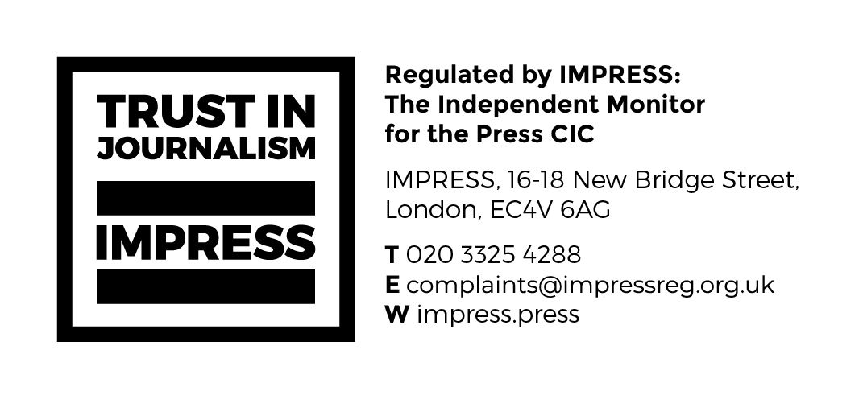

Review
- This policy is reviewed regularly and updated as required.

Adopted on:……………………………07/04/2022
Last reviewed:…………………………07/04/2022

